**JAVA Programming Questions**

**1. Palindrome Check Using a For Loop and If-Else Statement**

package JavaTask5;

import java.util.Scanner;

public class PalindromeCheck {

public static void main(String[] args) {

Scanner scanner = new Scanner(System.*in*);

System.*out*.print("Enter a string: ");

String str = scanner.nextLine();

boolean isPalindrome = true;

int length = str.length();

for (int i = 0; i < length / 2; i++) {

if (str.charAt(i) != str.charAt(length - i - 1)) {

isPalindrome = false;

break;

}

}

if (isPalindrome) {

System.*out*.println(str + " is a palindrome.");

} else {

System.*out*.println(str + " is not a palindrome.");

}

scanner.close();

}

}

**Output:**

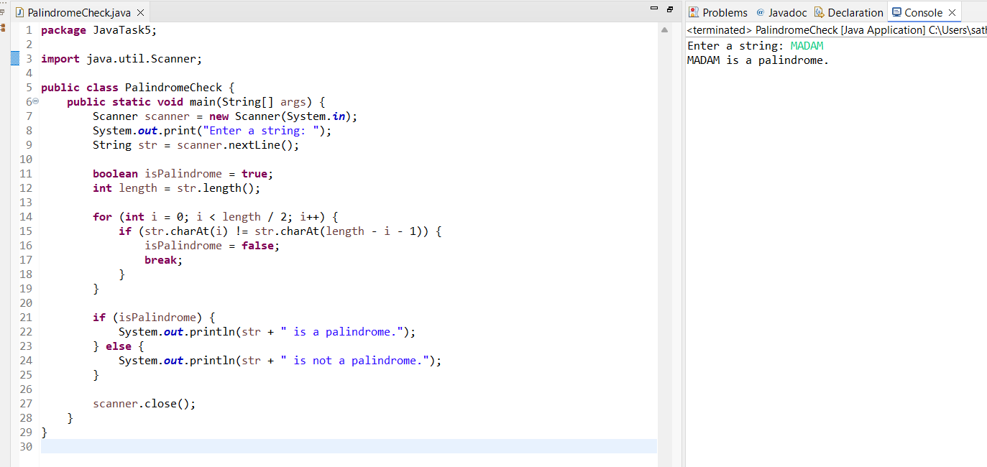

**2. Reverse a String Using a Loop**

**package** JavaTask5;

**import** java.util.Scanner;

**public** **class** ReverseString {

**public** **static** **void** main(String[] args) {

Scanner scanner = **new** Scanner(System.***in***);

System.***out***.print("Enter a string: ");

String str = scanner.nextLine();

String reversedString = "";

**for** (**int** i = str.length() - 1; i >= 0; i--) {

reversedString += str.charAt(i);

}

System.***out***.println("Reversed string: " + reversedString);

scanner.close();

}

}

**Output:**

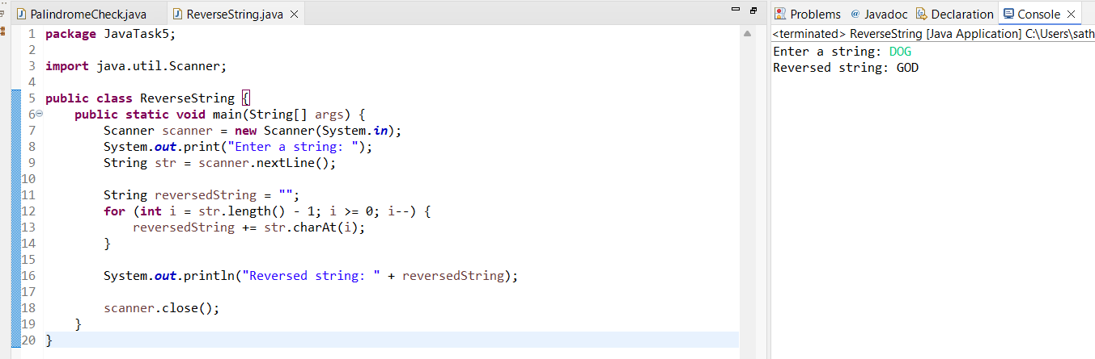

**3. Pattern Printing (Incremental Numbers)**

package JavaTask5;

import java.util.Scanner;

public class NumberPattern {

public static void main(String[] args) {

Scanner scanner = new Scanner(System.*in*);

System.*out*.print("Enter a number: ");

int n = scanner.nextInt();

int num = 1;

for (int i = 1; i <= n; i++) {

for (int j = 1; j <= i; j++) {

System.*out*.print(num + " ");

num++;

}

System.*out*.println();

}

scanner.close();

}

}

**Output:**

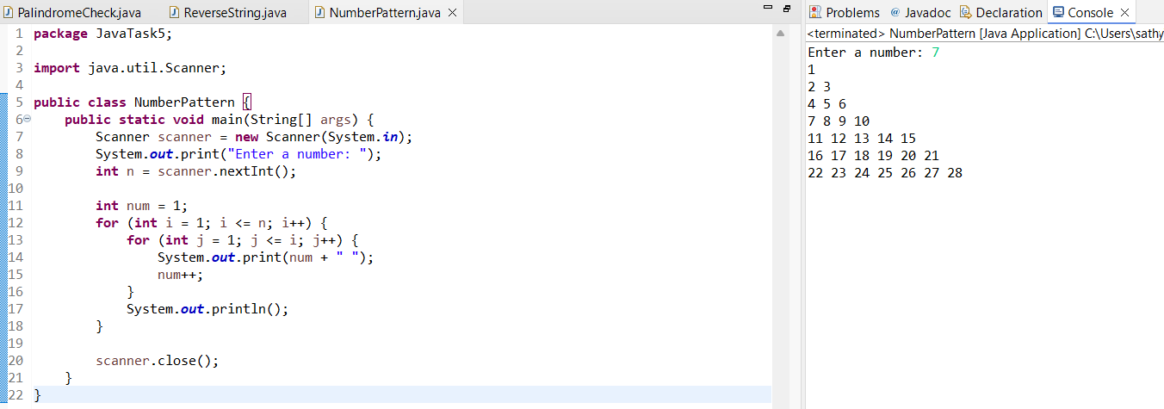

**4. Star Pattern Printing**

package JavaTask5;

import java.util.Scanner;

public class StarPattern {

public static void main(String[] args) {

Scanner scanner = new Scanner(System.*in*);

System.*out*.print("Enter a number: ");

int n = scanner.nextInt();

for (int i = 0; i < n; i++) {

if (i % 2 == 0) {

System.*out*.println("* ".repeat(i / 2 + 1).trim());

} else {

System.*out*.println("*".repeat(i / 2 + 1));

}

}

scanner.close();

}

}

**Output:**

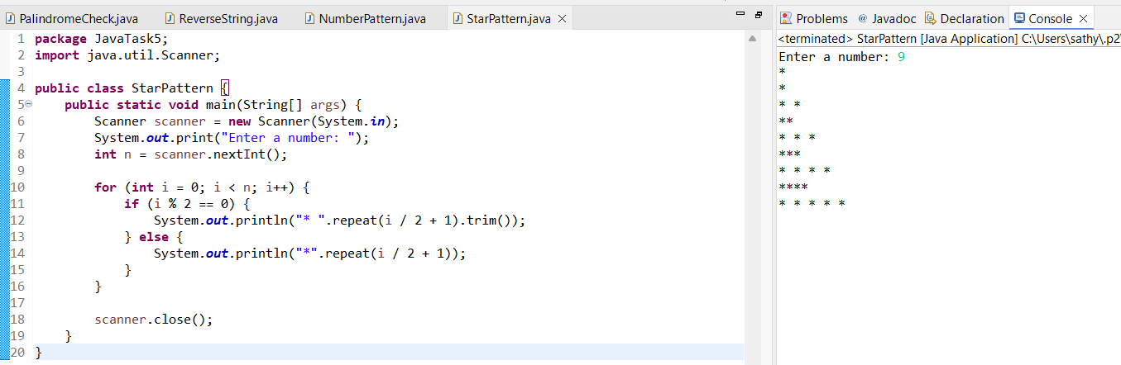

### **5. Anna University Grading System**

**package** JavaTask5;

**import** java.util.Scanner;

**public** **class** GradingSystem {

**public** **static** **void** main(String[] args) {

Scanner scanner = **new** Scanner(System.***in***);

System.***out***.print("Enter the marks: ");

**int** marks = scanner.nextInt();

**if** (marks > 100) {

System.***out***.println("Invalid Input");

} **else** **if** (marks == 100) {

System.***out***.println("S");

} **else** **if** (marks >= 90) {

System.***out***.println("A");

} **else** **if** (marks >= 80) {

System.***out***.println("B");

} **else** **if** (marks >= 70) {

System.***out***.println("C");

} **else** **if** (marks >= 60) {

System.***out***.println("D");

} **else** **if** (marks >= 50) {

System.***out***.println("E");

} **else** {

System.***out***.println("F");

}

scanner.close();

}

}

**Output:**

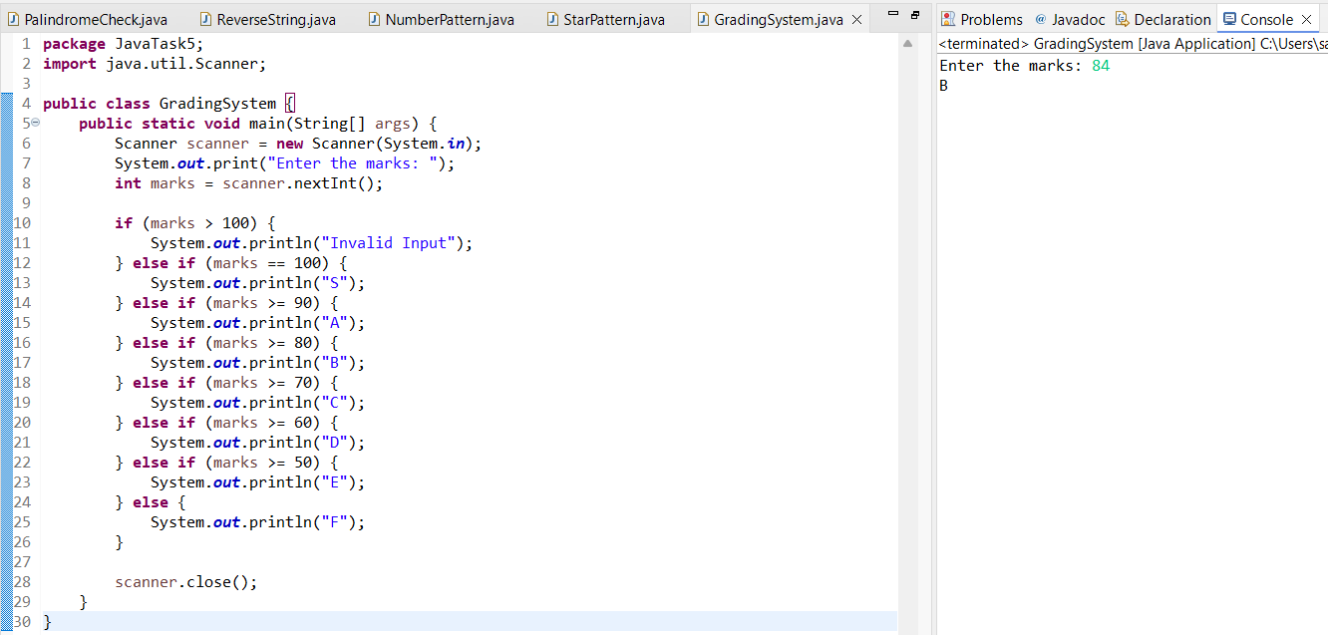

### 

### 

### 

### 

### 

### 

### 

### 

### 

### 

### **6. Hotel Tariff Calculation with Peak Season Adjustment**

package JavaTask5;

import java.util.Scanner;

public class HotelTariff {

public static void main(String[] args) {

Scanner scanner = new Scanner(System.*in*);

System.*out*.print("Enter the month (1-12): ");

int month = scanner.nextInt();

System.*out*.print("Enter room rent per day: ");

double roomRent = scanner.nextDouble();

System.*out*.print("Enter the number of days stayed: ");

int days = scanner.nextInt();

double tariff;

switch (month) {

case 4: case 5: case 6: case 11: case 12:

tariff = roomRent * 1.20 * days; // peak season

break;

default:

tariff = roomRent * days; // normal season

break;

}

System.*out*.printf("Total tariff: %.2f\n", tariff);

scanner.close();

}

}

**Output:**

